USDA Forest Service / Wildland Fire Chemical System (WFCS)

One stop shopping for all fire chemical reference materials !

http://www.fs.fed.us/rm/fire/

Select
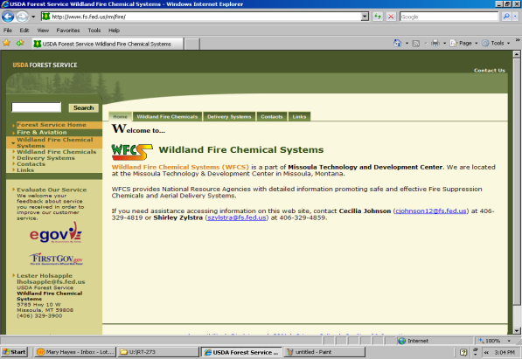

Click here for the Qualified Products List (QPL)
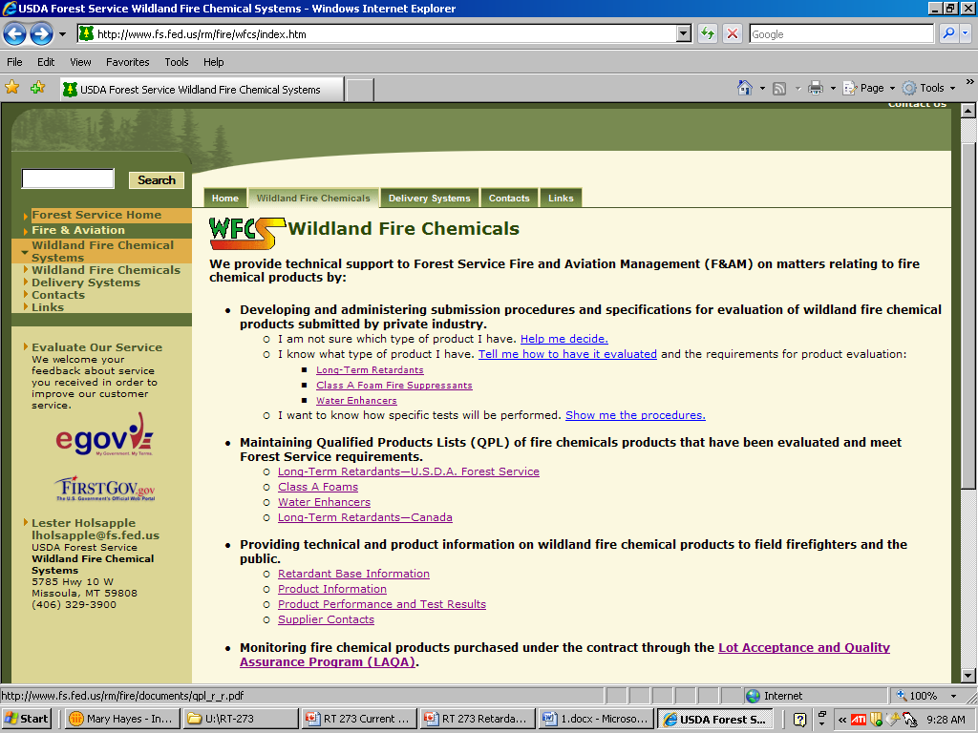

Mix Factor Tables

Click on the LAQA link to download the current Mix Factor Tables.
Check date to make sure you have the most current copy
This document is a MUST for SEAT Managers! It contains a list of approved products, mixing ratios and refractormeter readings for each type of retardant. It is a good idea to take multiple copies with you in the field to post at your base or provide loaders with a copy.

